PRS Pilot Project for Demonstration WP.2 - Partial Deliverables

GSA/GRANT/03/2016/3PfD

Alain Muls, Pascal De Kimpe: RMA--CISS (BE) Olivier Desenfans, Avag Tsaturyan: M3Systems Belgium (BE) Krzysztof Bronk, Adam Lipka, Rafał Niski: National Institute of Technology (PL)

# WP.2 Objectives and structure

## WP.2 Objectives

The WP.2 main objectives are:

* To perform laboratory and live RFI jamming, meaconing and spoofing tests
* To identify the waveforms that are most likely to interfere with the OS navigation signals. To apply those waveforms on a pre-operational P3RS2 Rx and national Rx demonstrators and a commercial Off-the-Shelf (OTS) Rx
* To create a list of RFI signals that could possibly degrade the PRS navigation service.

## WP.2 Structure

In order to achieve these objectives, the WP.2 has been divided into 4 sub-WP as follows:

* WP-2.1 : Using the pre-operational P3RS2 Rx
* WP-2.2 : Waveforms interfering with navigation services
* WP-2.3 : Pre-test with national PRS Rxs
* WP-2.4 : Interference testing of GNSSs navigation services in a controlled laboratory environment

Table 1 summarizes the involvement in terms of man power (in man days) of the 3PfD project partners in the WP.2 activities.

Table 1: Man days committed to WP.2

| **WP.xx** | **Activity** | __RMA__ | **M3SB** | **WTD81** | **TRAFICOM** | **NIT** | **FOI** |
| --- | --- | --- | --- | --- | --- | --- | --- |
| WP-2.1 | Using the pre-operational P3RS2 Rx | 2 | 10 | 15 | 17 | 40 | 20 |
| WP-2.2 | Waveforms interfering with Nav Sv | 2 | 10 | 2 | 18 | 20 | 32 |
| WP-2.3 | Pre-test with national PRS Rxs | 4 | 10 | 82 | 10 | 20 | -- |
| WP-2.4 | RFI laboratory testing | 4 | 20 | 30 | 50 | 30 | 40 |
| WP-2.x | End report | 3 | 5 | 15 | -- | -- | -- |
| **WP-2** | **Total** | **15** | **55** | **144** | **95** | **110** | **92** |

Due to the unavailability of the P3RS2 receivers, no work has been done on WP-2.1 and WP-2.3.

# WP.2 progress and status

## Description of test activities

During the interference tests several sub-aspects, described in the following sections, will be considered.

### Open navigation service RFI tests

Critical infrastructures rely today on the SPS navigation service of the GPS system mainly for timing and synchronisation purposes. These facilities are prone to (un)intentional jamming. Illegal cheap personal privacy devices, such as GPS jammers, are both a nuisance and cause for concern and can be easily obtained over the Internet. To evaluate the impact of such PPD devices specific jamming scenarios focus on OS GNSS frequencies only, more specifically the GPS SPS and Galileo OS navigation services. An added objective of these jamming tests is to demonstrate that the PRS navigation service is not affected by signals from current PPD devices by adding a PRS receiver to the test.

The impact is evaluated on different type of receivers from smartphones over cheap mass-market receivers up to geodetic type receivers. An added interesting aspect is to evaluate the behaviour of these receivers under different starting conditions:

* cold versus hot start,
* jamming conditions present when switching on the receiver,
* receiver operating in degraded environment (e.g. low CN0, low visibility, ...)

### PRS focused RFI robustness tests

A major PRS driver is the robustness of its signal, which protects it against jamming and spoofing. The objective of the PRS is to improve the probability of continuous availability of Galileo's SiS, in the presence of interfering threats, to those users with such a need. Demonstrating the PRS robustness will be done by applying similar (cfr section Open navigation service RFI tests) scenarios applied to the PRS frequency bands

### Meaconing**[1]**

Delaying a navigation service can be done by hardware or software. The former introduces a fixed time delay while the latter enables to vary the induced time delay which allows to better control the synchronisation between the direct and meaconed navigation services. Meaconing tests will be performed by delaying the navigation service either from the same antenna, or by using the signals collected through a second antenna located at a different location. When using the same antenna for both the direct and meaconed signal the expected result will be that a jump in position is observed, followed by the meaconed position converging to the original antenna position since the constant time delay will be absorbed by the receiver clock offset.

Again a two way approach is followed:

* open service signals will be meaconed while maintaining the undisturbed PRS navigation service,
* meaconing of the PRS navigation service. This will only be applied on a TUR-P laboratory receivers.[2]

### Spoofing

Spoofing attacks can only be done on open service signals since a PRS RFCS is not available. The objective of this test is to assess the robustness of PRS against spoofing attack.

## Test methodology

For the accountability of the different tests, each co-applicant creates a document describing the experiment containing different sections. The structure of the document should contain following sections:

* Experiment basic information
* Laboratory set-up
* Experiment test methodology
* Logged data
* Observations & remarks
* Appendix Example of document describing RFI tests is an example of this document.

## Receivers under investigation

The co-applicants involved in the WP.2 agreed that performing the same radio interference test scenarios represents an added value for the 3PfD project as results on a large number of GNSS receivers (from different MSs set) would be comparable. The initial list of GNSS receivers to be used are summarised in table 2.

Table 2: Proposed list of GNSS receivers

| Receiver | BE | SE | PL |
| --- | --- | --- | --- |
| P3RS2 | X | X | X |
| TUR-P |  | X |  |
| U-blox | X | X | X |
| AsteRx | X |  |  |
| Novatel |  |  | X |
| R330 |  |  | X |
| Garmin |  |  | X |
| JAVAD |  |  | X |
| Smart-phone |  |  | X |

# BE contribution

## Achievements and activity progress

### Preparation of the test infrastructure

In close collaboration with M3SB, the department RMA-CISS prepared a calibrated laboratory infrastructure for performing repeatable RFI tests on different navigation services using simultaneously multiple GNSS receivers. A mobile infrastructure for dynamic recording of GNSS data by multiple receivers; combined with the possibility to connect a spectrum analyser and a RP device, mounted in military vehicle was created and operated during tests.

As far as possible, the receivers involved in a test scenario are configured in identical ways (e.g. cut-off angle, minimum carrier-to-noise ratio, automatic gain control, ...)

#### Laboratory test infrastructure

Figure 1 represents the set-up of the calibrated laboratory infrastructure at RMA-CISS. Tests can be conducted either on the live GNSS signals or using selected navigation signals from a GNSS test suite. This GNSS test suite allows to select signals from an OS RFCS or a RP device allowing to perform purely RFI tests or create meaconing or spoofing navigation signals. GNSS vulnerability assessment is performed using a (vector) signal generator creating the interference signals and a spectrum analyser to analyse the spectral impact of these signals.

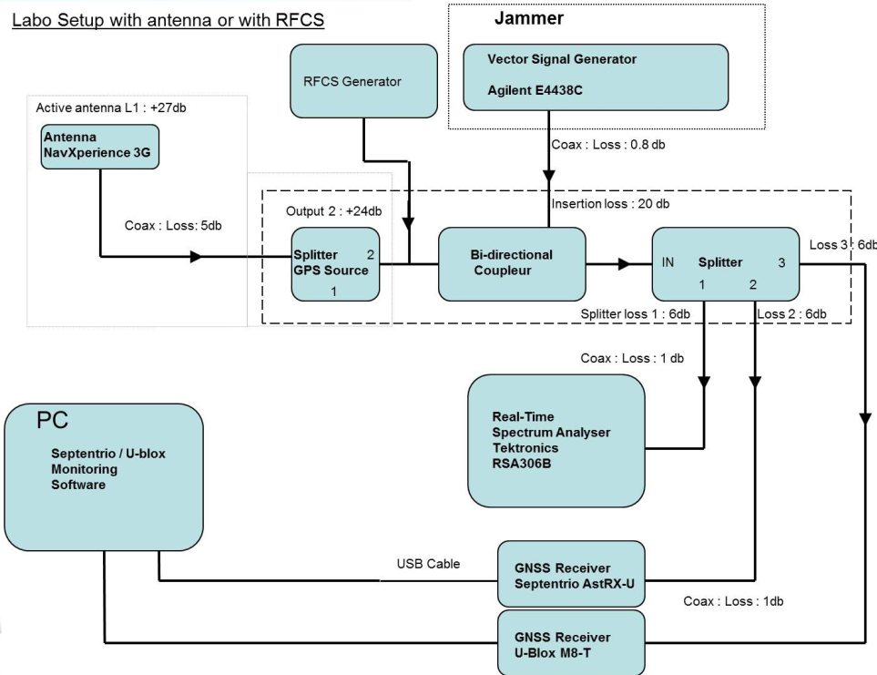

Figure 1: Calibrated laboratory infrastructure

To enable (semi-)automated and repeatable test scenarios, automation of the generation of the interference signals is being developed by a close collaboration between RMA-CISS and M3SB. The automation process is based on scripts that control the interference generation tool (and the GNSS signal generator/replayer if used instead of real signal). The scripts fully defined the interference (frequency, modulation, bandwidth, power, …) and the evolution of these parameters along time.

Such approach enables to easily repeat exactly the same interference scenario on different GNSS signals, or conversely to perform a sensitivity analysis of the interference parameters. Both options are key for performing benchmark or comparison of the different GNSS signals performances under the same interference conditions, or the impact of various type of interferences on the same GNSS signal.

### Mobile test infrastructure

Performing RFI tests in real world conditions is not obvious due to national interference regulations. Though very limited controlled real life RFI tests can be done at military bases under strict conditions, it is also important to verify whether unintentional interferences affect the reception of different navigation services. For this purpose a mobile test infrastructure (Figure 2) has been created and can be mounted in a military vehicle.

The receivers mounted on board of the vehicle can be selected based on the test performed and receiver availability. A RP device can also be integrated in the set-up.

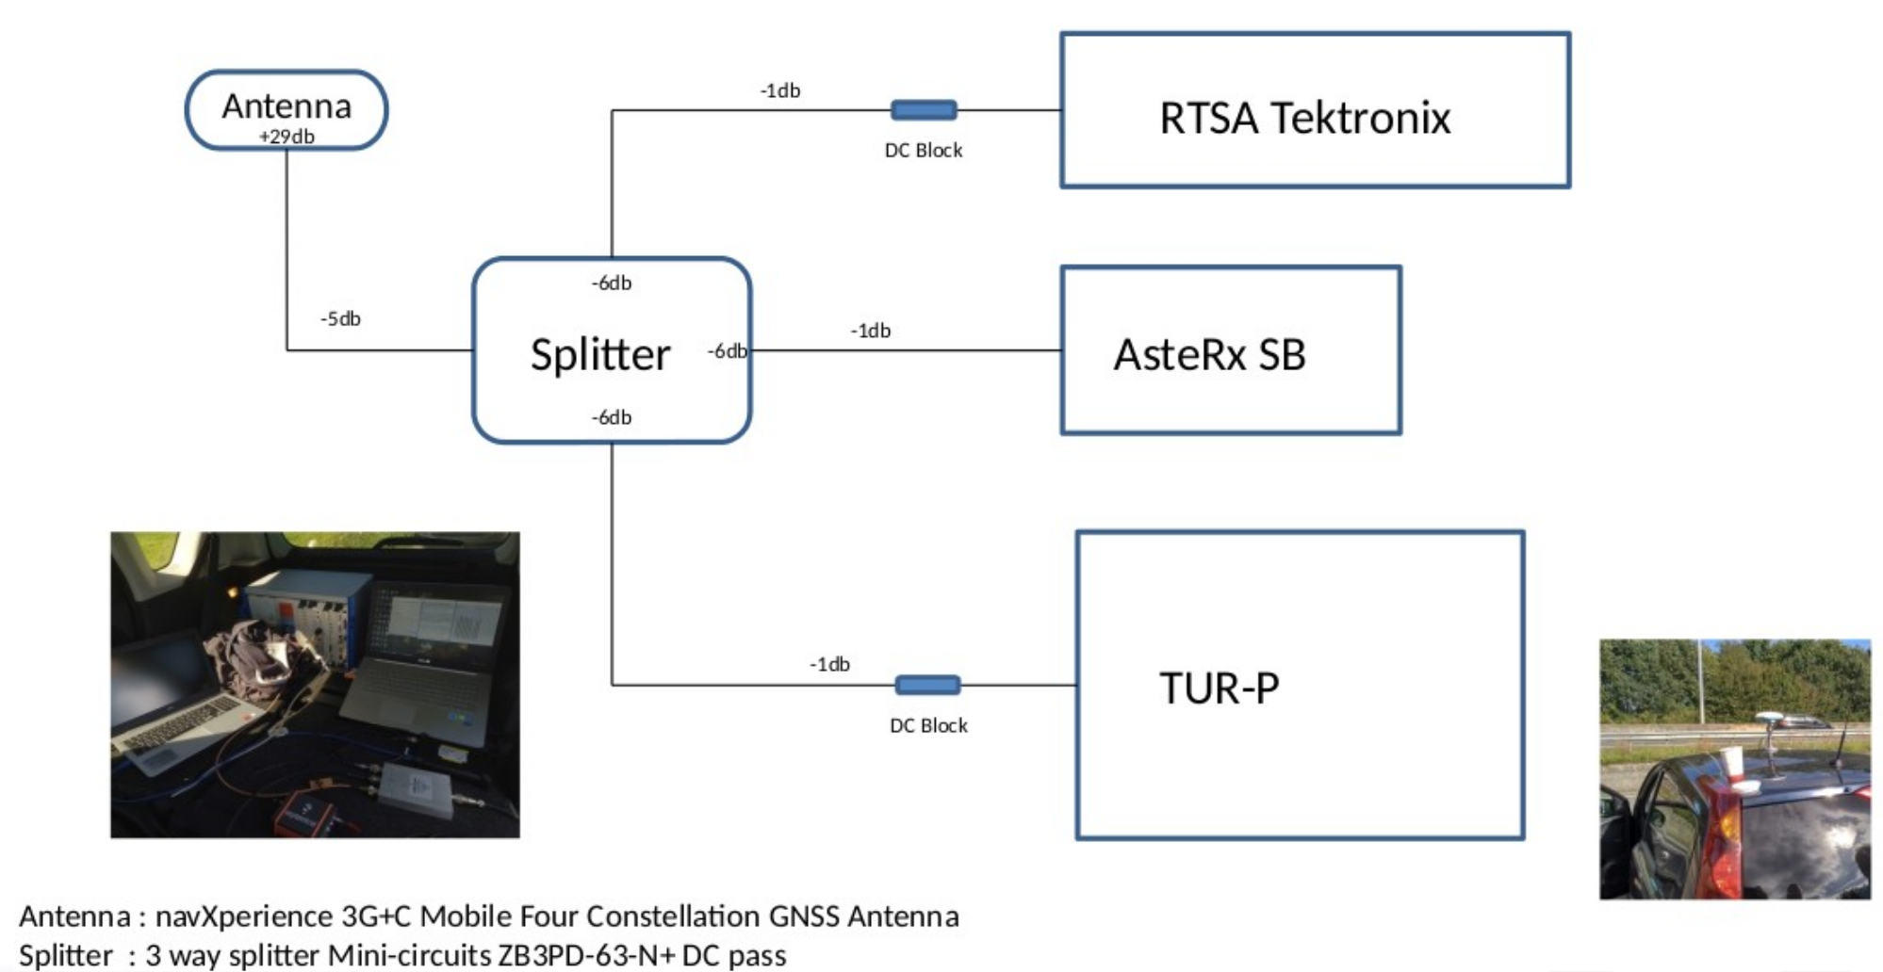

Figure 2: Mobile infrastructure

### Developed test tools

Anticipating that the P3RS2 receiver is only able to output RINEX or NMEA data-files, all developed test tools use these standard formats as input. A collection of python scripts allow to investigate different metrics associated with the interference tests described in section Description of test activities.

#### The PNT oriented python scripts perform:

* conversion of binary proprietary formats from Septentrio and u-Blox receivers to RINEX observables and navigation files
  + observation and navigation files can be created containing only Galileo data, only GPS data or a combination of Galileo and GPS data,
* processing of the obtained RINEX files using the open source library [RTKLib](http://www.rtklib.com)
* analysis, statistics and plotting of the obtained results
  + UTM and ellipsoidal height coordinates (figure 6), UTM scatter plot (figure 7 and 8) and coordinate distribution (figure 9)
  + pseudo-range residuals (figure 10) and distribution per PDOP bin (figure 11)
  + carrier-to-noise plots (figure 12) and distribution per PDOP bin (figure 13)
  + ...

#### The interference oriented python scripts:

* use the RINEX observables data for creating plots of the collected data such as
  + pseudo-ranges (figures 16 and 17),
  + signal-to noise ratios (figures 18 and 19),
  + Doppler shift,
* per satellite system or per satellite.
* figures 14 and 15 show the importance to investigate unintentional interferences on the PRS E6 frequency band. This interference has been further investigated by the 3PfD consortium and is described in 2 documents:
  + 3PfD-RMA-0045-UNC-E6Interference.pdf an unclassified document describing the status of DVB-T transmitters in different MSs including simulation results of the effect on PRS reception,
  + 3PfD-RMA-0046-EUC-E6Interference-BE.pdf CONFIDENTIEL UE/EU CONFIDENTIAL classified document describing tests performed by RMA-CISS.
* These documents have been handed over to GSA at PRS Special WG of October 2019.

## Planned activities for the next period

The following key points will be further elaborated by M3S and RMA:

* integration of the P3RS2 receiver in the test infrastructure,
* identification of the most harmful interference signals,
* finalization of the scenarios scripts,
* improvement of the KPIs analysis for vulnerability tests (especially automation),

# PL contribution

## NIT's measurements station

For the purpose of the smartphones' GNSS receivers testing within the 3PfD WP.2 activities, the NIT has developed the high-flexibility measurement station (figure 3).

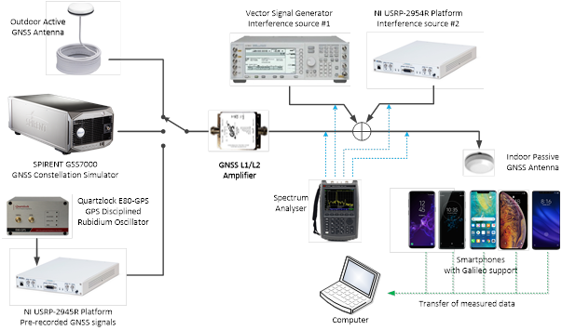

Figure 3: Measurement Station

The main elements of the platform are:

* GPS Source GNSS-3A - GNSS outdoor active antenna,
* Spirent GSS7000 - GNSS Constellation Simulator,
* National Instruments USRP-2945R - SDR Platform,
* Quartz-clock E80 - GPS - GPS Disciplined Rubidium Oscillator,
* GPS Source A11 - L1/L2 Amplifier,
* Agilent N5182A - Vector signal generator,
* GPS Source GNSS-3P - GNSS passive antenna,
* Keysight N9914A - Spectrum Analyser,
* Different smartphone manufacturers with GNSS raw measurements capabilities: Apple, Google, Huawei, Samsung, Sony, Xiaomi,
* Computer with the Measurement applications.

For the purpose of the jamming tests, the isolated measurement location in the basement of the NIT's building has been selected. Thanks to this solution, no live GNSS signals are coming directly to the station and no jamming signals are going out from the building and the measurement station does not affect the nearby GNSS receivers.

The station allows three different GNSS signal sources:

* live signal from the active GNSS antenna, installed on the building's roof top,
* pre-recorded GNSS signal from the USRP SDR Platform,
* generated signal from the SPIRENT GSS7000 GNSS Constellation Simulator.

In the next step the GPS/GALILEO/GLONASS/BEIDOU systems signals are amplified with the LNA, combined with the jamming signals and then transmitted by the GNSS passive antenna. In each step the signals are measured by the spectrum analyser.

The high-accuracy reference position (RTK) of the NIT's building roof top antenna has been also determined for the purpose of the position accuracy tests during jamming measurements.

Using the vector signal generator and the NI USRP platform it is possible to generate the different jamming signals:

* Unmodulated signals:
  + CW (single-tone),
  + Multi-tone,
  + Pulse and swept.
* Modulated and noise signals:
  + Narrowband and broadband (including the whole GNSS bandwidth),
  + Constant envelope and high PAPR modulations,
  + Pulse and swept signals,
  + Filter shaped signals,
  + Single- and two-carrier signals.

During the tests, the following signal parameters will be changed:

* CIR,
* signal duration,
* swept time,
* swept frequency range,
* impulse duration,
* signal bandwidth.

The measurement station consists of different smartphones equipped with the GNSS raw measurements capabilities:

* Apple iPhone Xs Max,
* Google Pixel 3 XL,
* Huawei Mate 20 Pro,
* Samsung Galaxy S9+,
* Samsung Galaxy Note 9,
* Sony Xperia XZ3,
* Xiaomi Mi 8 PRO 8.

Due to compatibility problems between different smartphone manufacturers, the Android Measurement App was developed by the NIT, on the basis of the "*White Paper on using GNSS Raw Measurements on Android devices*", published by the GNSS Raw Measurements Task Force. The application (figure 4) was developed using Java programming language for Android operation system and uses the new Android API (API 24), which enables reading of the GNSS parameters measured by the GNSS chip sets in the smartphones (so-called "*GNSS raw measurements*").

During the jamming tests the application allows to perform the operations listed below for GPS, Galileo and GLONASS systems in different frequency bands: L1/E1/G1 and L5/E5:

* NMEA logging with basic GNSS parameters on smartphones,
* satellite status and all available Raw Measurements logging on smartphones in CSV file,
* RINEX OBS data logging on smartphones (created on the basis of raw measurements).

The source code documentation is available for interested parties.

Due to the problems with access to navigation data in some smartphones, during the tests, the RINEX NAV data need to be logged on PC from NTRIP server (ephemeris stream RTCM3EPH @ products.igs-ip.net).

The second application developed by the NIT is the PC Measurement App to give a PC user the ability to control the Android application running on a smartphone connected via USB to the PC. The application uses the PowerShell scripts for Microsoft Windows 10 and it allows:

* to control the Android Measurement App on all smartphones via USB connection,
* to perform parallel measurements on all smartphones,
* to collect the data logged on smartphones.

The measurement data collected during tests will be analysed - among others - using RTKLIB ver. 2.4.3, a dedicated software tool and Microsoft Excel.

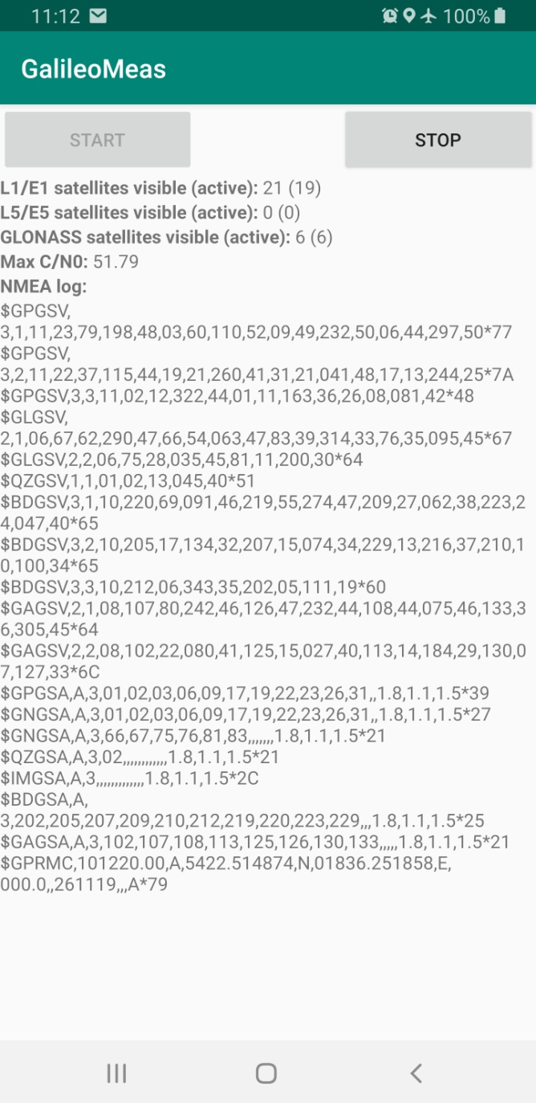

Figure 4: The Android Measurement App API

## Performed measurement

Some of the initially planned measurements within WP.2 have already been performed.

The first tests with the live GNSS signals were conducted with the listed below jamming signals:

* Unmodulated two-tone signals on L1/E1 and G1 frequencies,
* Broadband AWGN noise signal covering L1/E1 frequency bands (20MHz),
* Broadband AWGN noise signal covering L1/E1 and G1 frequency bands (60 MHz).

During the test, the C/I ratio for the two-tone L1/E1+G1 jamming signal has changed from -20 dB to -45 dB with 1 dB step every 2 minutes. In case of the broadband AWGN noise, the C/N ratio has changed from -10 dB to -40 dB with 1 dB step every 2 minutes.

The test were conducted for the following smartphone manufacturers: Apple, Google, Huawei, Samsung, Sony, Xiaomi. The measurement station is shown in figure 5.

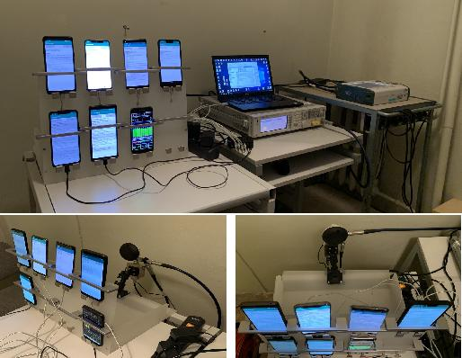

Figure 5: TThe measurement station during tests

The sample RTKLIB analysis results for selected smartphones (Samsung Galaxy S9+ and Sony Xperia XZ3), consisting in the number of active GNSS satellites, SNR for GALILEO and position error E-W, is shown in the figures 20 to 23.

## Preliminary conclusions

On the basis of conducted tests, the first conclusions can be pointed. As expected, the broadband AWGN noise effectively jams all GNSS receivers in all smartphones, however, different cutting off C/N levels were observed for different smartphones. In case of the unmodulated multi carrier signal used for jamming, the observed effects were different on various smartphones - for example the GNSS receiver in Samsung Galaxy S9+ has been successfully disturbed, while the GNSS receiver in Sony Xperia Z3 has been almost unaffected.

Therefore, the results obtained so far allow to confirm the validity of the adopted measurement methodology.

Some initial tests with recorded GNSS signals have also been conducted. The NIT has encountered some challenges during these tests. One of them was the recording of the GNSS signals with low signal to noise ratio - the solution was the usage of the active GNSS antenna and additional LNA. The second issue was the synchronisation between recording and transmission of the GNSS signals. In that case the proposed solution was the usage of the GPS disciplined rubidium oscillator. The first tests have shown, that the GNSS receivers in Samsung smartphones require more time to set the time and position from recorded signal comparing with, for example the Xiaomi smartphone.

## Planned activities for the next period

For the next period the planned NIT's activities on WP.2 are:

* further development of the Android Measurement Application,
* further jamming scenarios and usage of different signal sources (live, pre-recorded, generated),
* usage of the SPIRENT GSS7000 GNSS Constellation Simulator, supporting GPS/GALILEO/ GLONASS/BEIDOU systems on L1/E1/G1 and L5/E5 frequencies, allowing tests for both static and dynamic scenarios with single/multi-system and -frequency signals,
* comparative analysis of the impact of the different jamming signals on GNSS receivers in different manufacturers' smartphones and in various scenarios.

# FI contribution

## Achievements and activity progress

FGI has an existing test setup for the analysis of the effect of different waveforms onto different receivers. This setup is based on a vector signal generator and has been successfully tested and validated within the STRIKE3 project. FGI is waiting to receive the P3RS2 so that it can be used with the same setup.

## Planned activities for the next period

Once the P3RS2 receiver is available, FGI plans to compare the effect of commonly encountered interference waveforms on the PRS receiver with the observed effect on OS receivers, as reported in the STRIKE3 project. Common waveforms include continuous waves, sweeps, and ticks. These waveforms need to be tailored so that they affect the PRS frequencies, not just the OS channels.

Traficom and the FDRA will decide on their actions after gaining the first experiences of the P3RS2.

# Acronyms

| **Acronym** | **Description** |
| --- | --- |
| 3PfD | PRS Pilot Project for Demonstration |
| C/A | Coarse/Acquisition |
| CISS | Department Communication, Information, Systems & Sensors |
| CN0 | Carrier-to-Noise ratio |
| GNSS | Global Navigation Satellite Signals |
| GSA | European GNSS Agency |
| J/S | Jammer to Signal ratio |
| M3SB | M3Systems Belgium |
| Nav Sv | navigation services |
| OS | Open Service |
| OTS | Off-the-Shelf |
| PPD | Personal Privacy Devices |
| PRS | Public Regulated Service |
| RFCS | radio Frequency Constellation Simulator |
| RFI | radio Frequency Interference |
| RMA | Royal Military Academy |
| RP | Record & Playback device |
| Rx | receiver |
| SPS | Standard Positioning Service |
| VSG | Vector Signal Generator |
| WP | Work Package |
| SiS | Signal-in-Space |
| TUR-P | Test Unit Receiver - PRS |
| NMEA | National Marine Electronics Association |
| RINEX | Receiver Independent Exchange Format |
| DOP | Dilution of Precision |
| PDOP | Position DOP |
| SDR | Software Defined Radio |
| USRP | Universal Software Radio Peripheral |
| LNA | Low Noise Amplifier |
| RTK | Real Time Kinematic |
| NTRIP | Network Transport of RTCM via Internet Protocol |
| C/I | Carrier to Interference ratio |
| C/N | Carrier to Noise ratio |

# Appendix

## Example content for document describing RFI tests by RMA - M3SB

### Experiment basic information

* **Operator(s)**: Pascal De Kimpe
* **Location**: RMA-CISS-LabD
* **Date**: 17 January 2020
* **Description**: Demonstration of the benefit of spectral separation between OS and PRS navigation services

### Laboratory set-up

* **Signal source**: live Galileo & GPS signals
* **Equipment**:
  + Vector Signal Generator mark & type
  + Spectrum analyser mark & type
  + Receivers
    - u-Blox M8T
    - AsteRx-U
    - TUR-P
* **Additional information**

### Experiment test methodology

The spectral separation between the Open Services of GPS (L1-C/A, L1C data & pilot, L2 CM & CL, L5 I&Q) and Galileo (E1 0S, E5 (combined, a or b) I&Q) allow to deny access to freely available GNSS navigation signals while maintaining PRS (E1 PRS and / or E6 PRS) navigation capability. The normal used jammers (civil and military) target the L1 centre frequency with a bandwidth of 6 to 8 MHz. Demonstrate the spectral separation aspect by jamming according to the set-up in table 3.

Table 3: Set-up of OS RFI jamming demonstrating spectral separation

| **Parameter** | **Value** |
| --- | --- |
| **Targeted constellation** |  |
| - targeted navigation service | See table 4 |
| - targeted frequency | L1 @ 1575.42 MHz |
| - targeted bandwidth | +-[2 / 4 / 8] MHz |
| - power of targeted signal | -130 dBm |
|  |  |
| **Preserved navigation service** |  |
| - preserved navigation service | Galileo PRS |
| - preserved frequency | E1A (and E6A) |
|  |  |
| **Receivers** | TUR-P, P3RS2, AsteRx, PolaRx, ublox, DAGR |
| - start status | warm start (PNT & Ephemeris available) |
| - logging frequency | 10 Hz |
| - troposphere model | Saastamoinen |
| - ionosphere model | Klobuchar |
|  |  |
| **Jamming scenario** |  |
| - jamming signal | See table 5 |
| - interference power | [-120 : 5 : -60 : -5 : -30] dBm |
| - J/S ratio | [10 : 5 : 70 : -5 : 10] dB |
| - timing | [5 : 2 : 31 : 2 : 57] min |
|  |  |
| **Location** |  |
| - Use of RFCS | 60N / 24E / 30m |
| - RMA Antenna | 50.8440152778N / 4.3929283333E / 151.39179 |
|  |  |
| **Metrics** |  |
| - Carrier-to-Noise | L1-C/A, Gal OS, Gal PRS E1 |
| - number of satellites | in PNT fix |
| - loss of first satellite | time |
| - loss of PNT | time |
| - reacquisition of first satellite | time |
| - reacquisition of PNT | time |
| - AGC (automatic gain control) | if available |
| - PNT accuracy | log vs time |
| - recovery time or J/S level | time needed during or after scenario |
| - pseudo-range / Doppler relative accuracy | against geometric distance or initial conditions |

Table 4: Navigation services targeted

| **System** | **Navigation Service** |
| --- | --- |
| GPS | SPS service (C/A @ L1) |
| Galileo | OS E1BC (see table 6) |
|  |  |
|  | *Unlikely influence on PRS because no common spectrum*[3] |
| GPS | L2 CM / CL |
| GPS | L5 I & Q |
| Galileo | E5a & E5b (see table 6) |

Table 5: Used jamming signals

| **Jamming signal** | **Characteristics** |
| --- | --- |
| White noise | to be detailed |
| Frequency swipe | to be detailed |
| wide swept frequency with fast repeat rate | to be detailed |
| narrow band signal at L1 carrier frequency | to be detailed |
| triangular and triangular wave swept frequency | to be detailed |
| tick swept frequency | to be detailed |

### Logged data

Proposed directory structure:

RMA-LABD-20200117-EUR  
 RMA-LABD-20200117-UNC-RFIonGPSCA.(docx | md | pdf)  
 ASTX  
 SBF files of ASTX receiver  
 uBLOX  
 binary data of uBlox receiver  
 RTSA  
 data from spectrum analyser  
 ...

### Observations & Remarks

During the experiment the following was observed:

* observation 1
* observation 2
* ...

## Characteristics of main lobes for Galileo's open service

Table 6: Metrics for main Galileo OS lobes

| **OS Band** | **Frequency** | **Offset** | **Bandwitdh lobe** |
| --- | --- | --- | --- |
| **E1BC** | 1575.420 MHz | 1.023 MHz | 2 1.023 = 2.046 MHz |
| E1BC low | 1574.397 MHz |  | [1573.374 ... 1575.420] MHz |
| E1BC High | 1576.443 MHz |  | [1575.420 ... 1577.466] MHz |
|  |  |  |  |
| **E5a** | 1191.795 MHz | -15.345 MHz | 2 10.23 = 20.46 MHz |
| ESa main lobe | 1176.450 MHz |  | [1166.220 ... 1186.68] MHz |
|  |  |  |  |
| **E5b** | 1191.795 MHz | +15.345 MHz | 2 10.23 = 20.46 MHz |
| ESb main lobe | 1207.140 MHz |  | [1196.910 ... 1217.370] MHz |

## Example of plots created by RMA developed tools

### PNT oriented plots

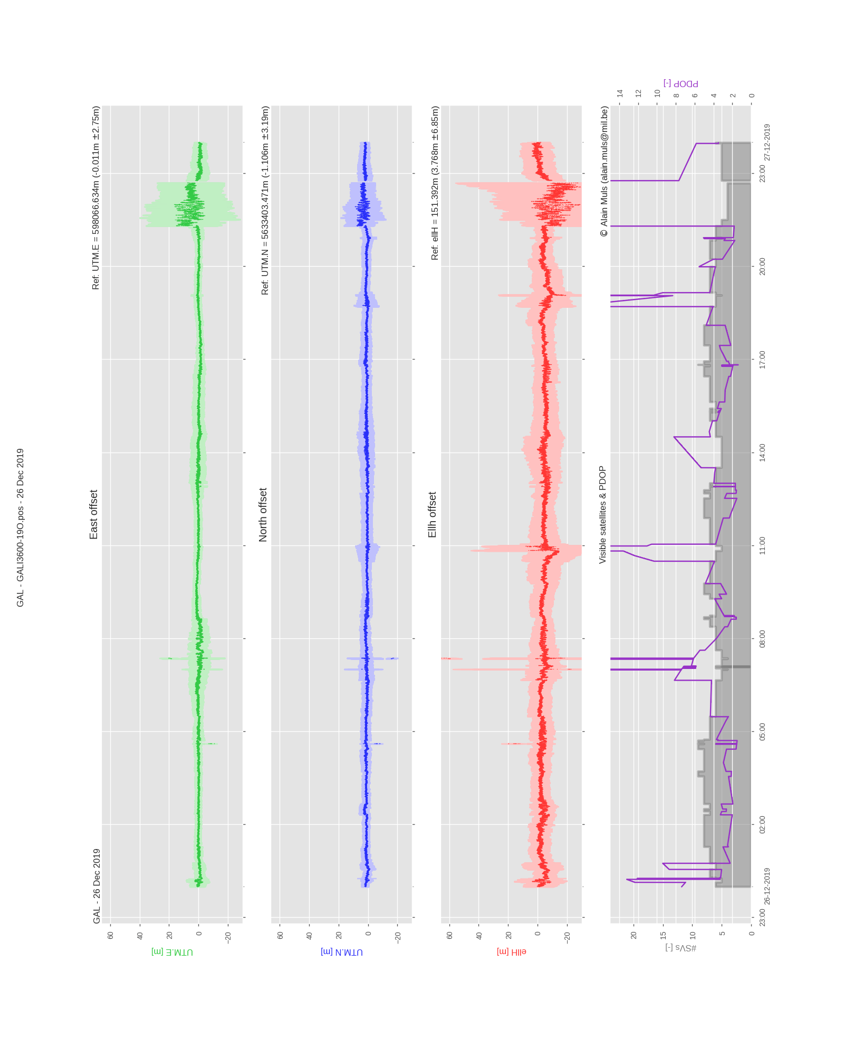

Figure 6: UTM height versus time plot

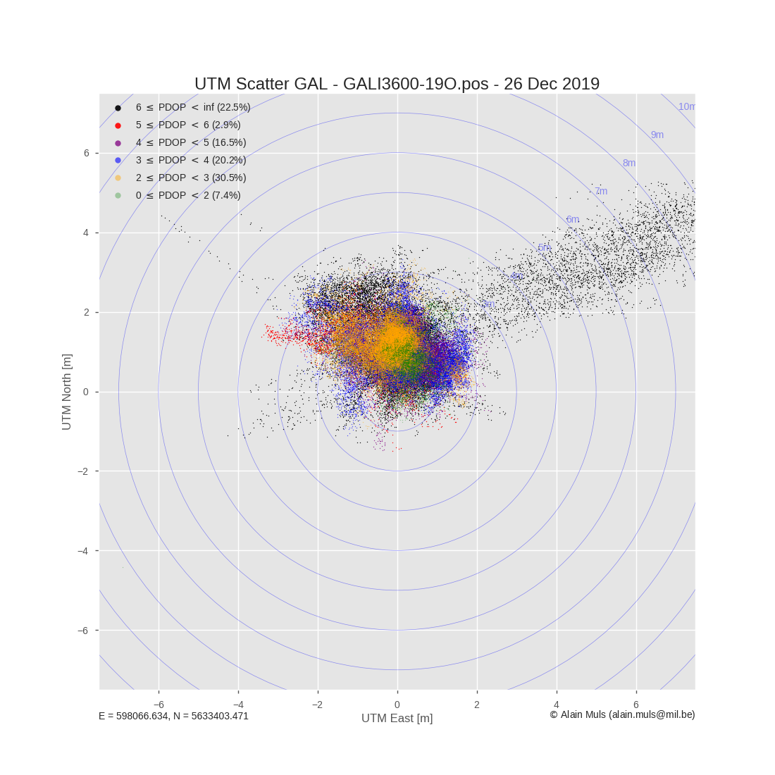

Figure 7: UTM scatter plot

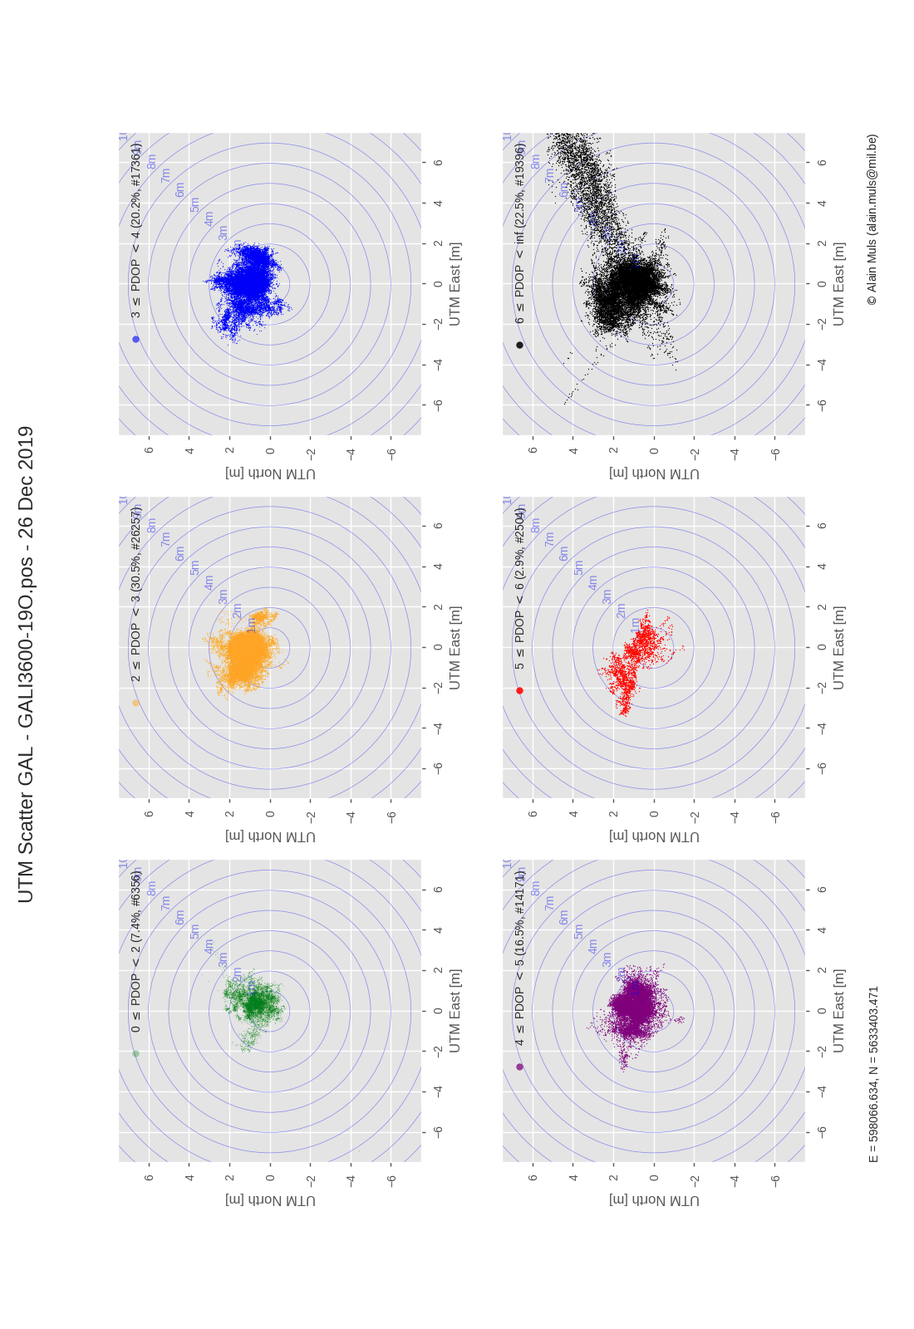

Figure 8: UTM scatter plot per PDOP bin

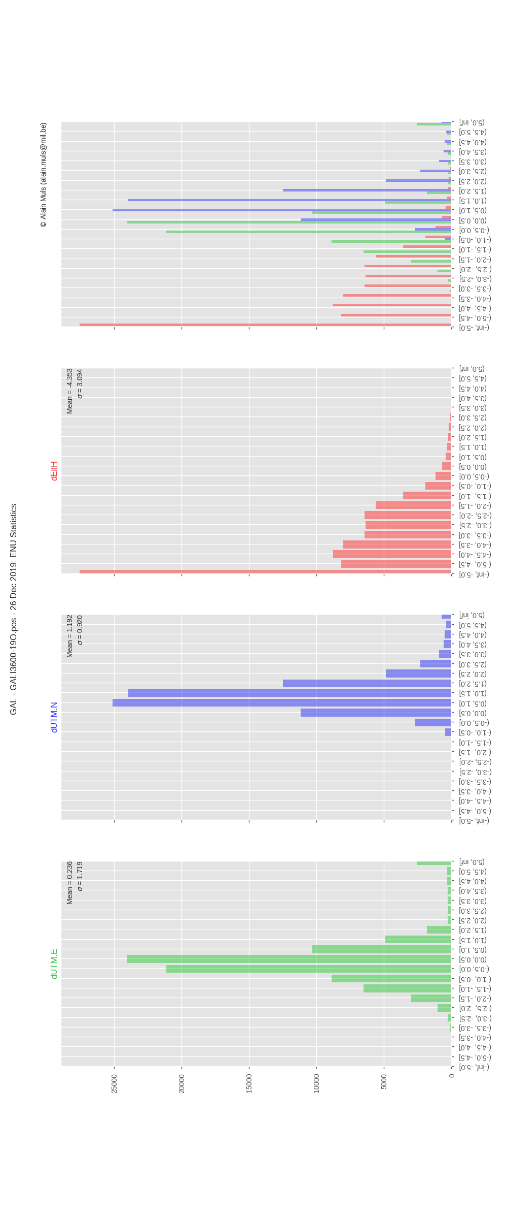

Figure 9: UTM distribution plot

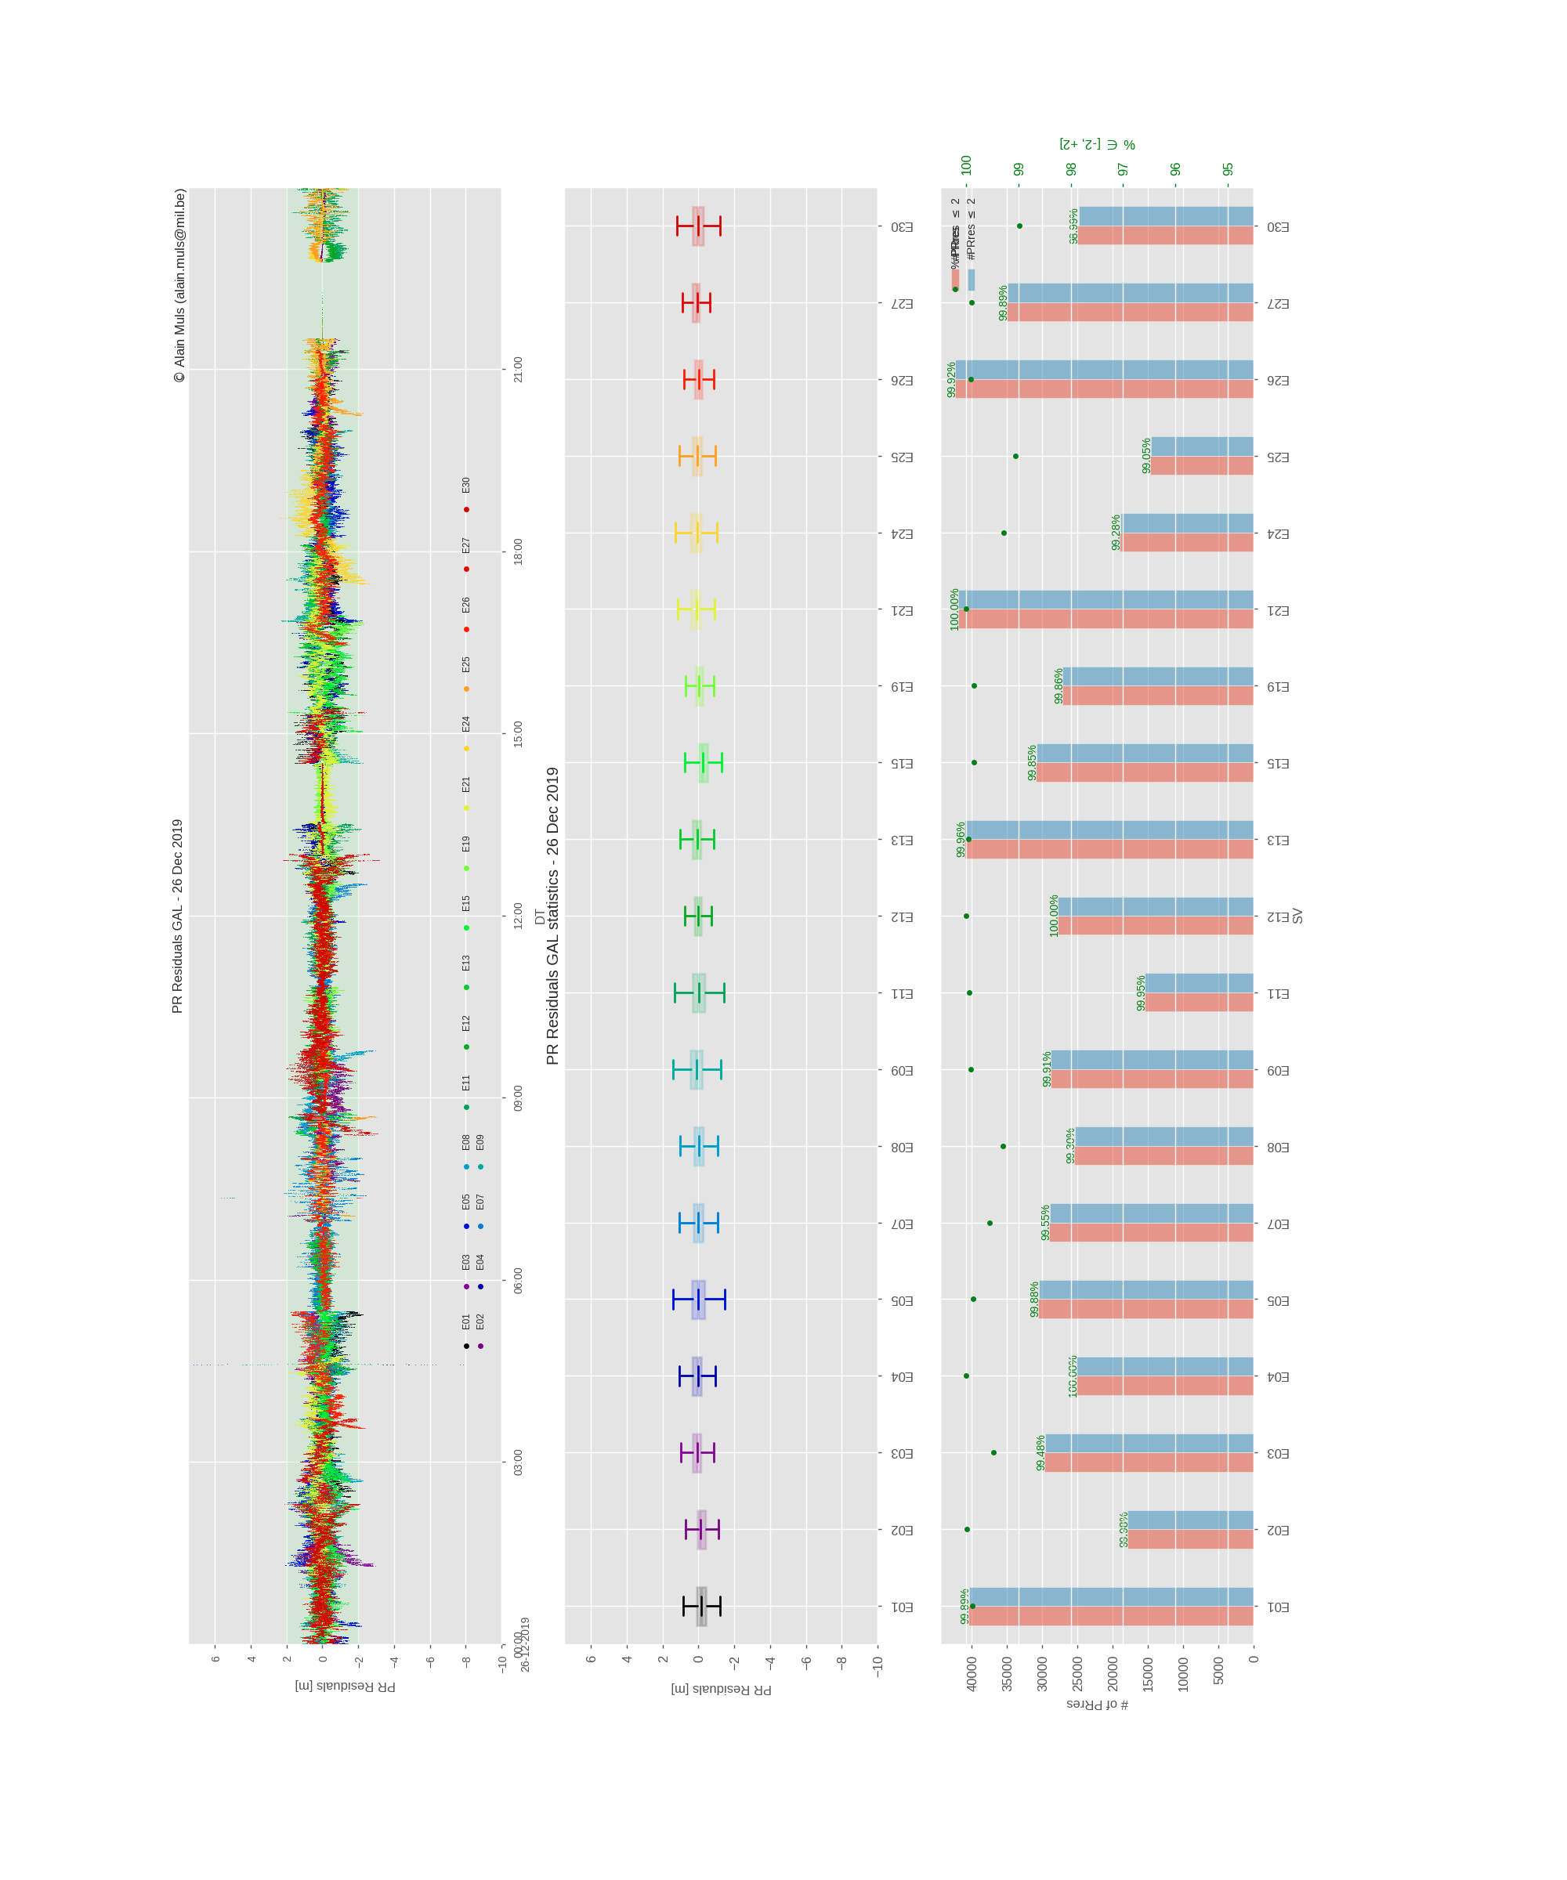

Figure 10: Pseudo-range residuals analysis plot

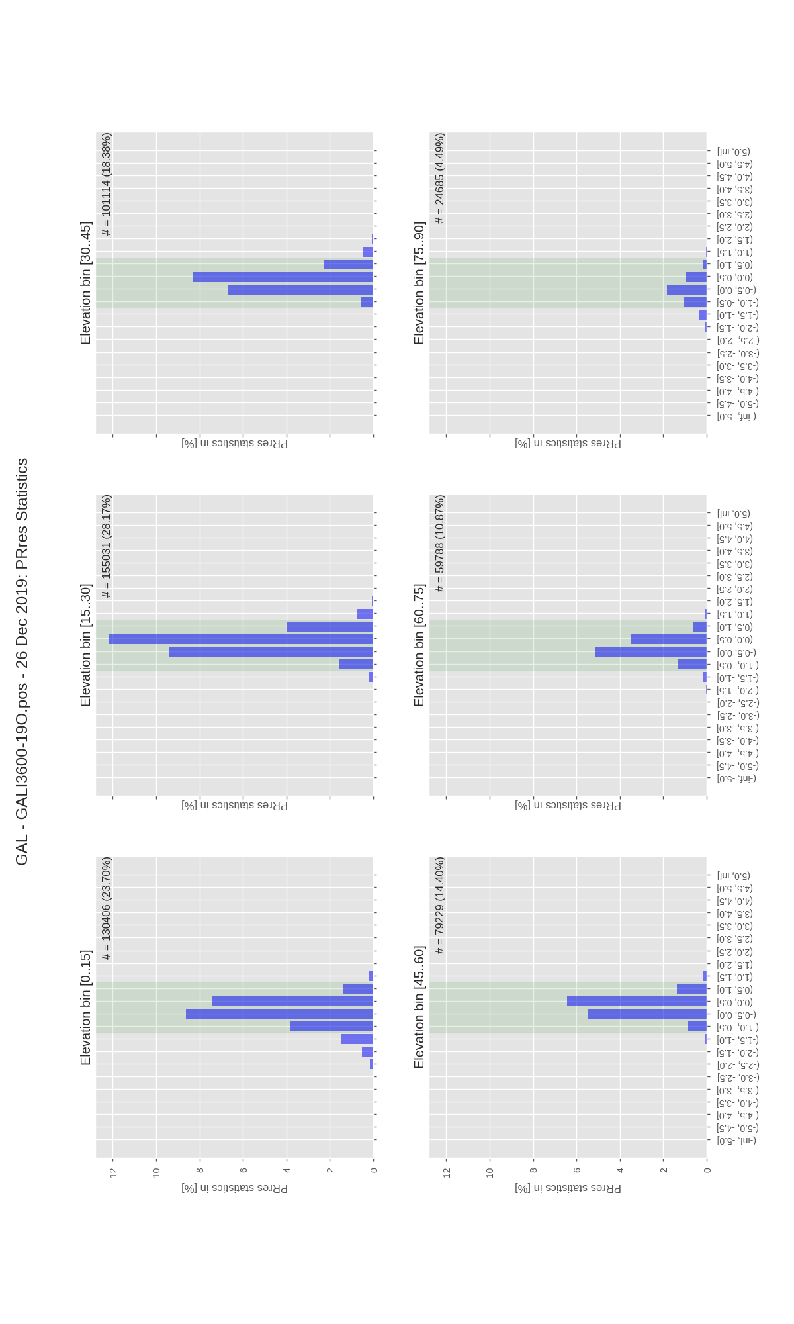

Figure 11: Pseudo-range distribution per PDOP bin plot

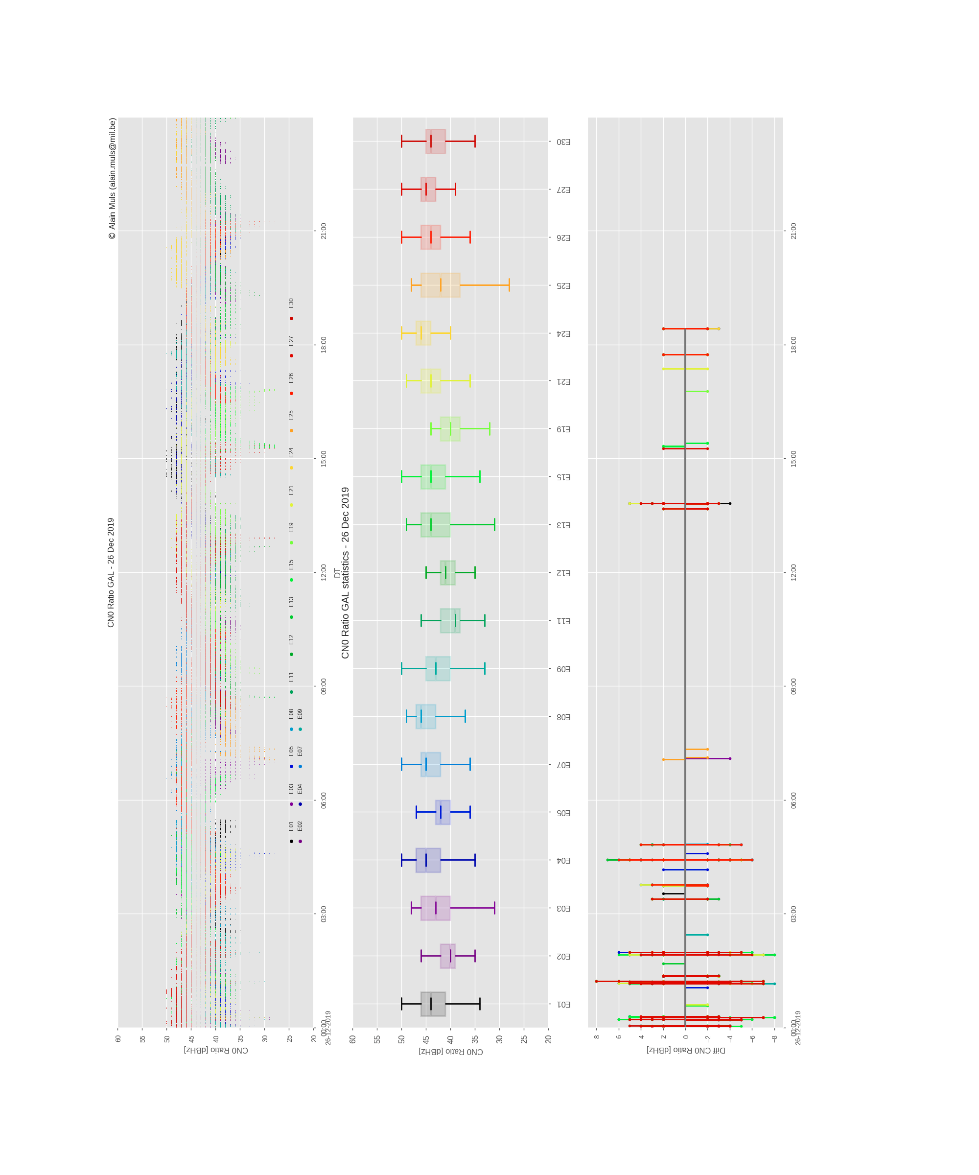

Figure 12: CN0 analysis plot

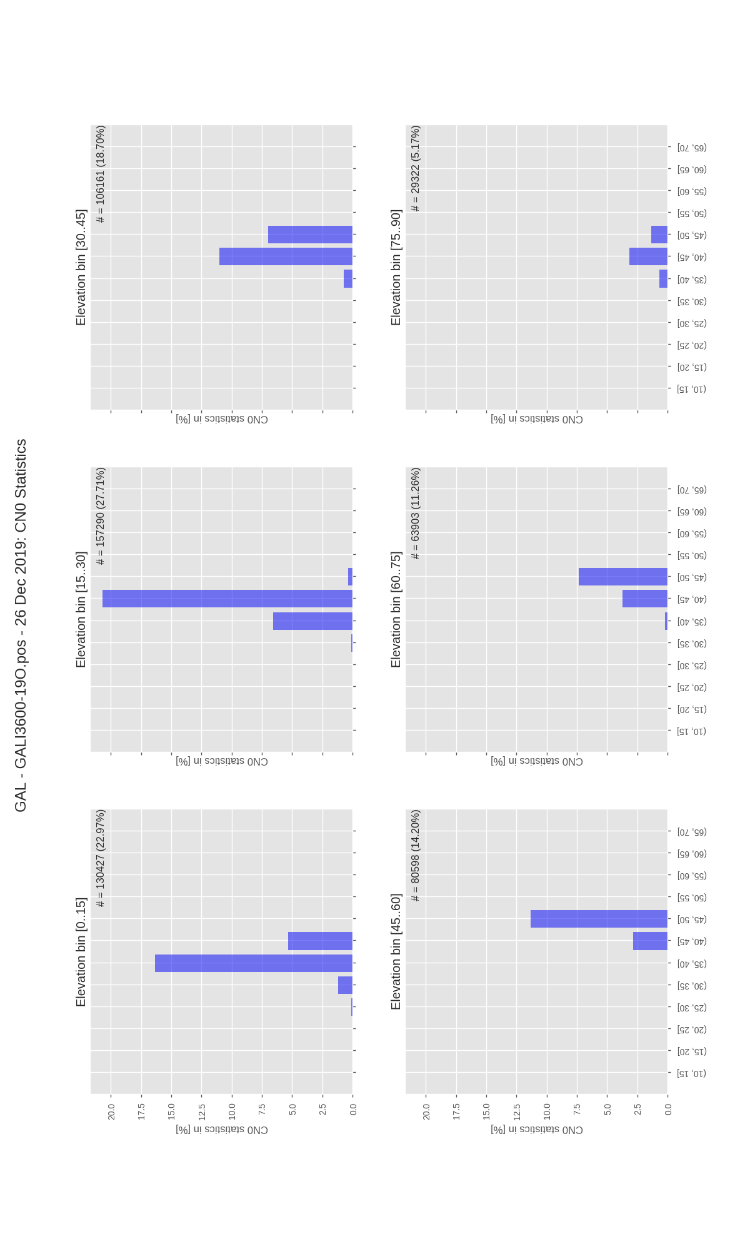

Figure 13: CN0 distribution per PDOP bin plot

### RFI oriented plots

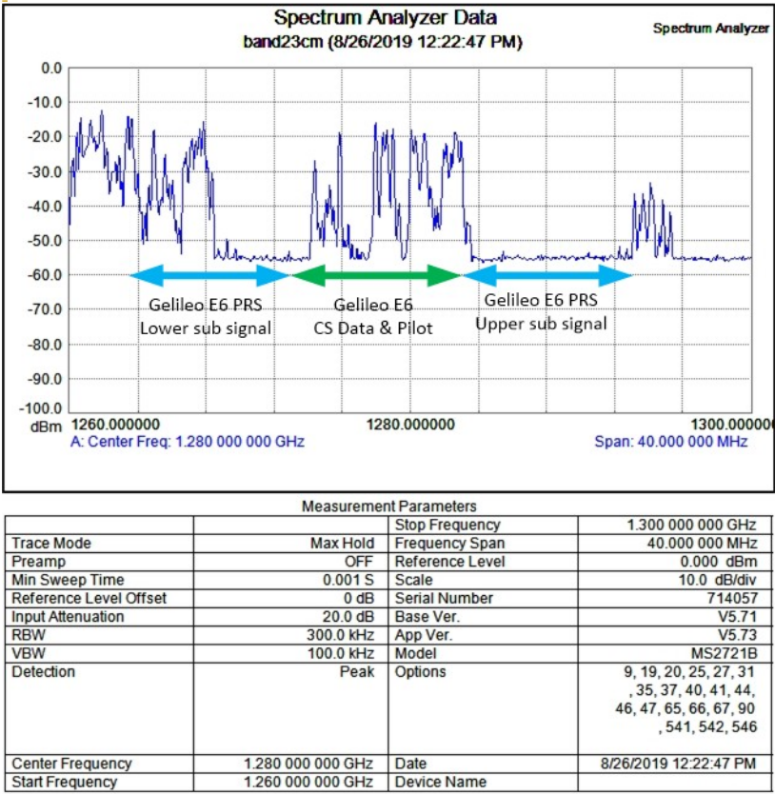

Figure 14: E6 Interference Signal @ Gdansk (PL)

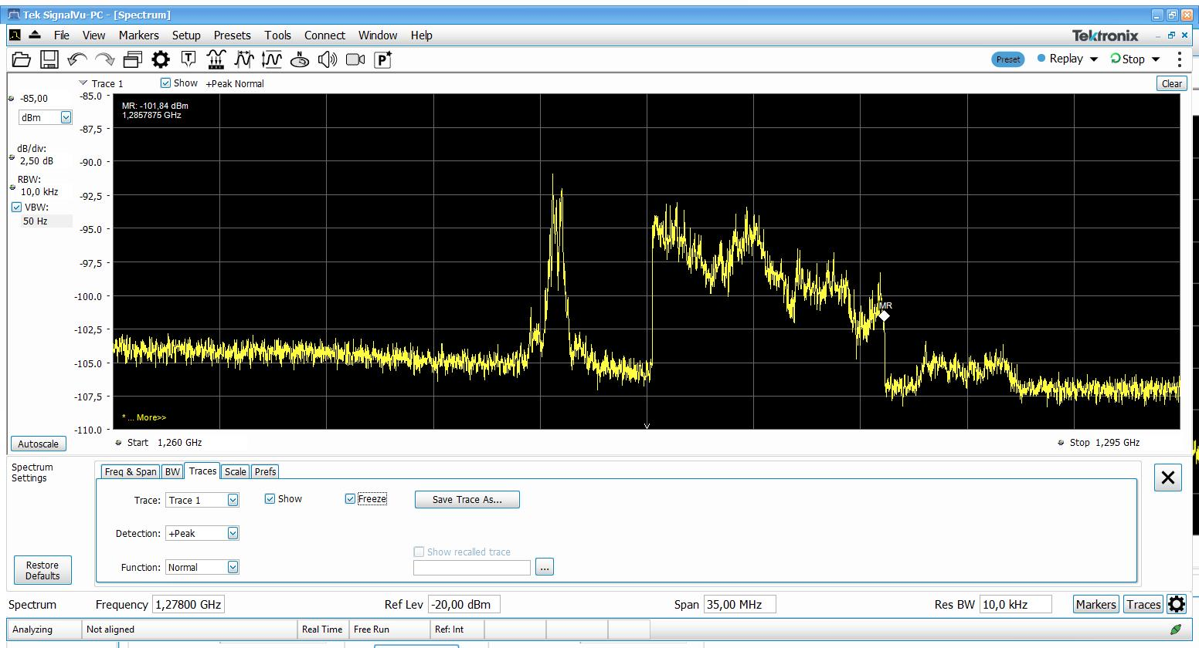

Figure 15: E6 Interference Signal @ Brussels (BE)

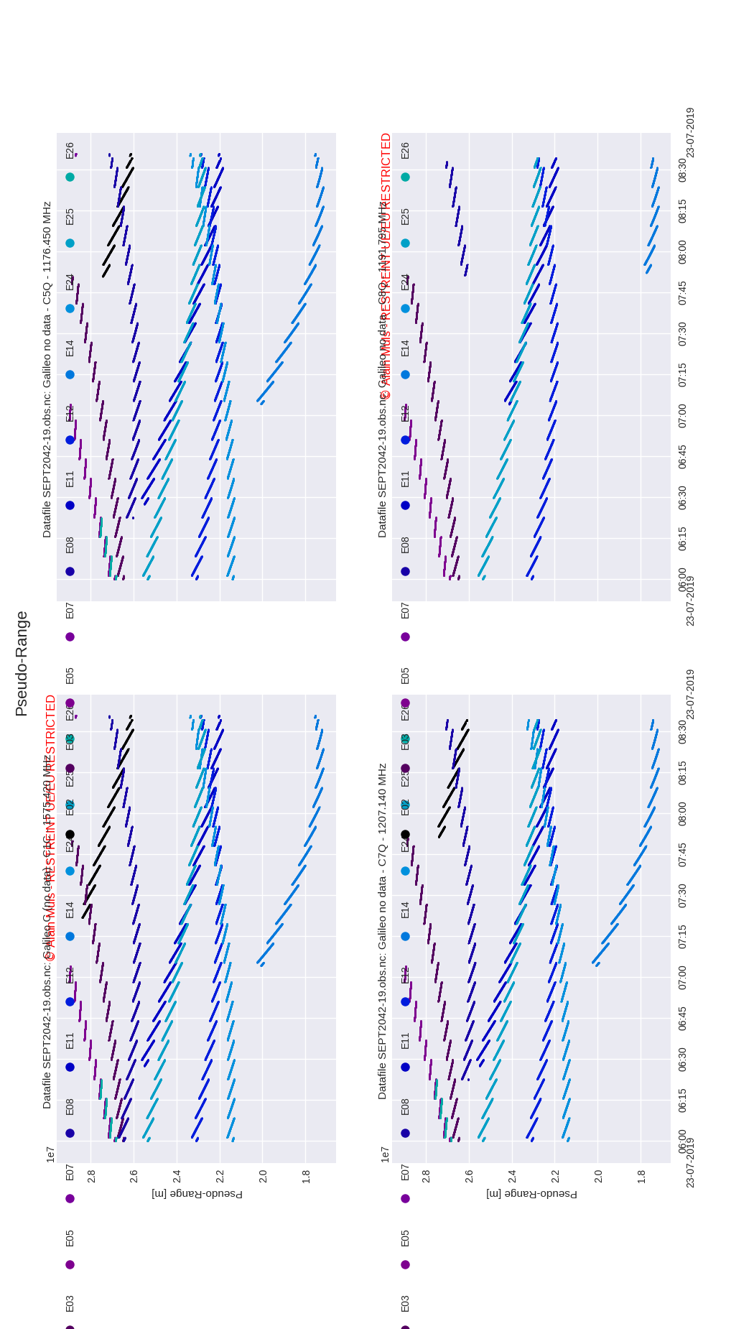

Figure 16: Galileo OS PR

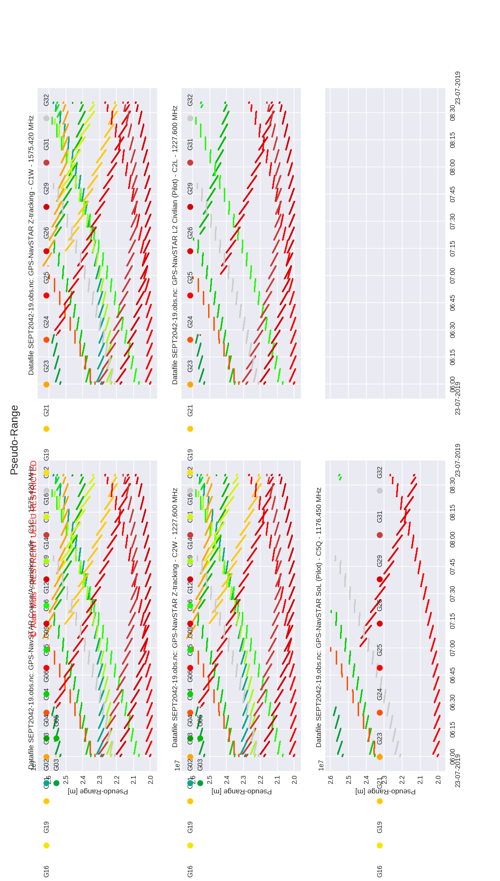

Figure 17: GPS OS PR

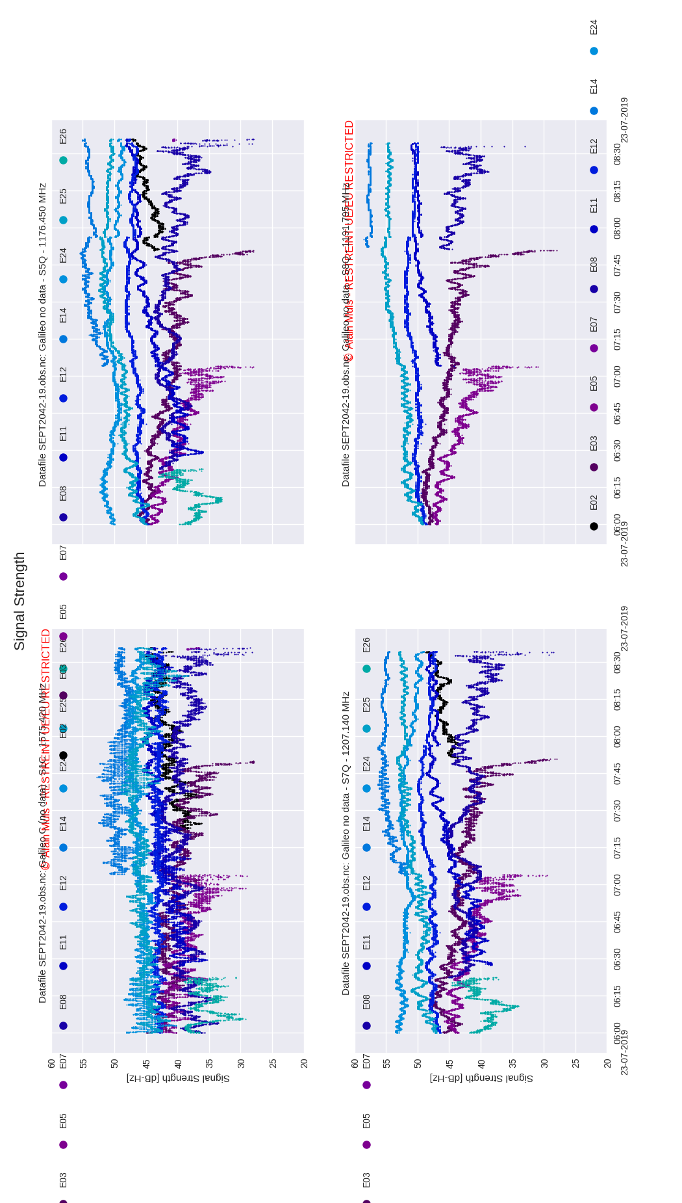

Figure 18: Galileo OS CN0

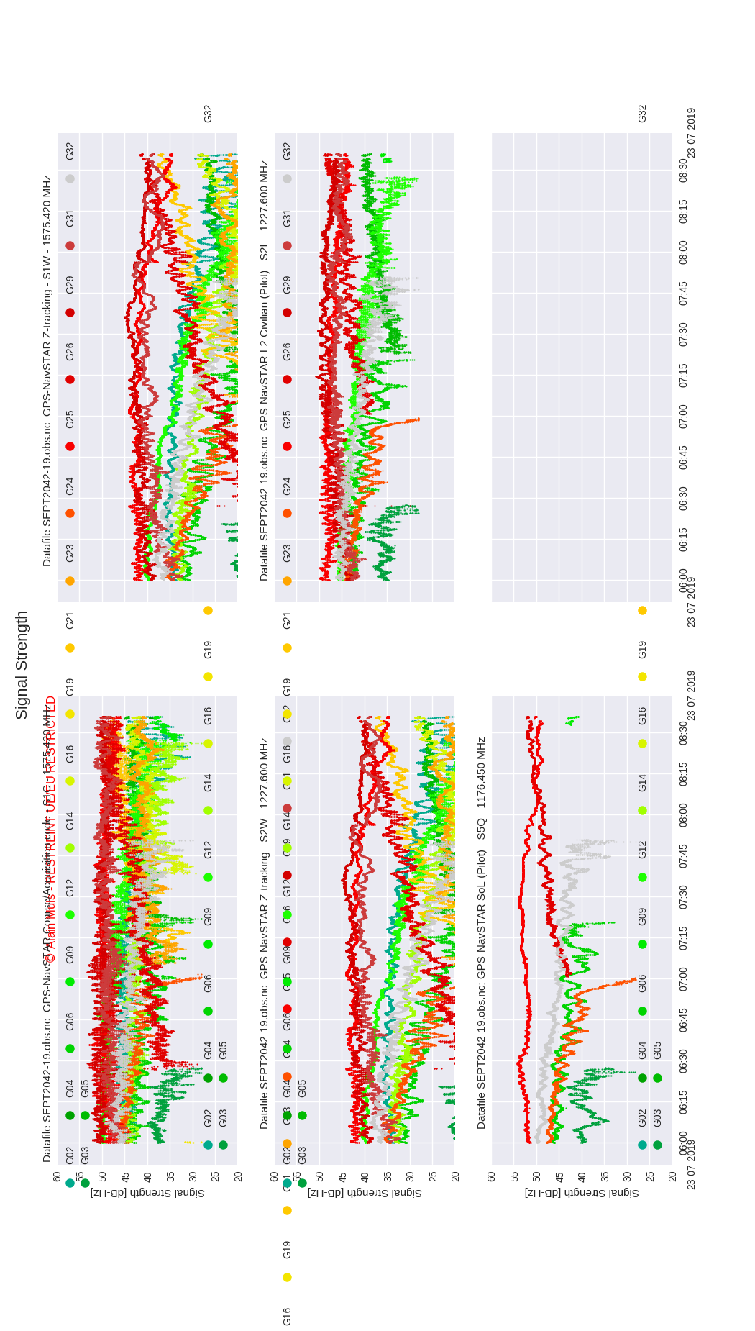

Figure 19: GPS OS CN0

## Plots showing RFI influence on smartphone by NIT

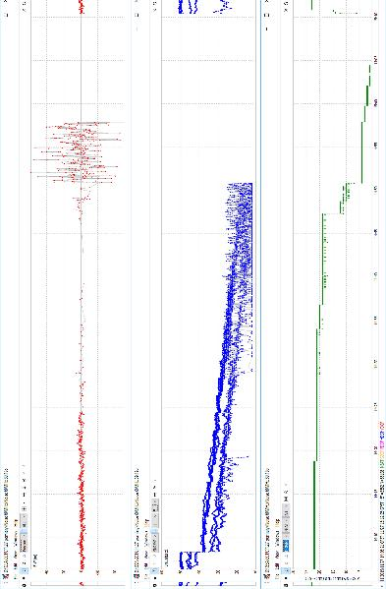

Figure 20: The sample results for Samsung Galaxy S9+ and the Broadband AWGN noise 60 MHz

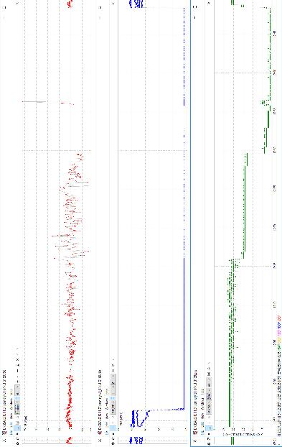

Figure 21: The sample results for Samsung Galaxy S9+ and the Two-Tone L1/E1+G1 jamming signal

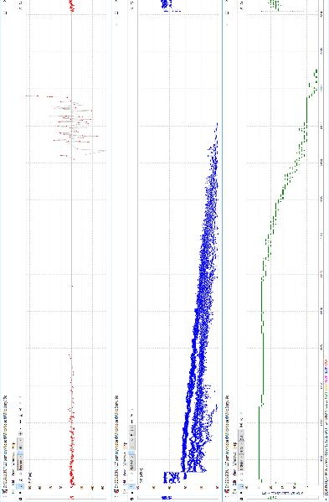

Figure 22: The sample results for Sony Xperia XZ3 and the Broadband AWGN noise 60 MHz

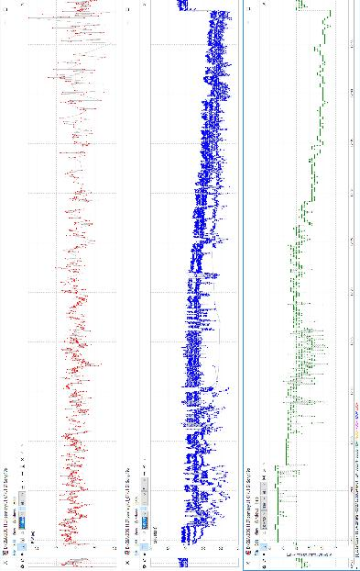

Figure 23: The sample results for Sony Xperia XZ3 and the Two-Tone L1/E1+G1 jamming signal

1. Meaconing and spoofing provoke similar effects. In this document meaconing is used when a time delay is applied to the navigation signals from a GNSS constellation while spoofing refers to using a navigation service generated by a RFCS.
2. Meaconed or spoofed signals will not be applied to the P3RS2 receiver since this could cause a tampering condition erasing the keys from the P3RS2 receiver.
3. These services are out of the PRS bands but this would demonstrate that security forces can also deny access to these services without losing PRS navigation capability.